Date: 05.10.2024

Case-01

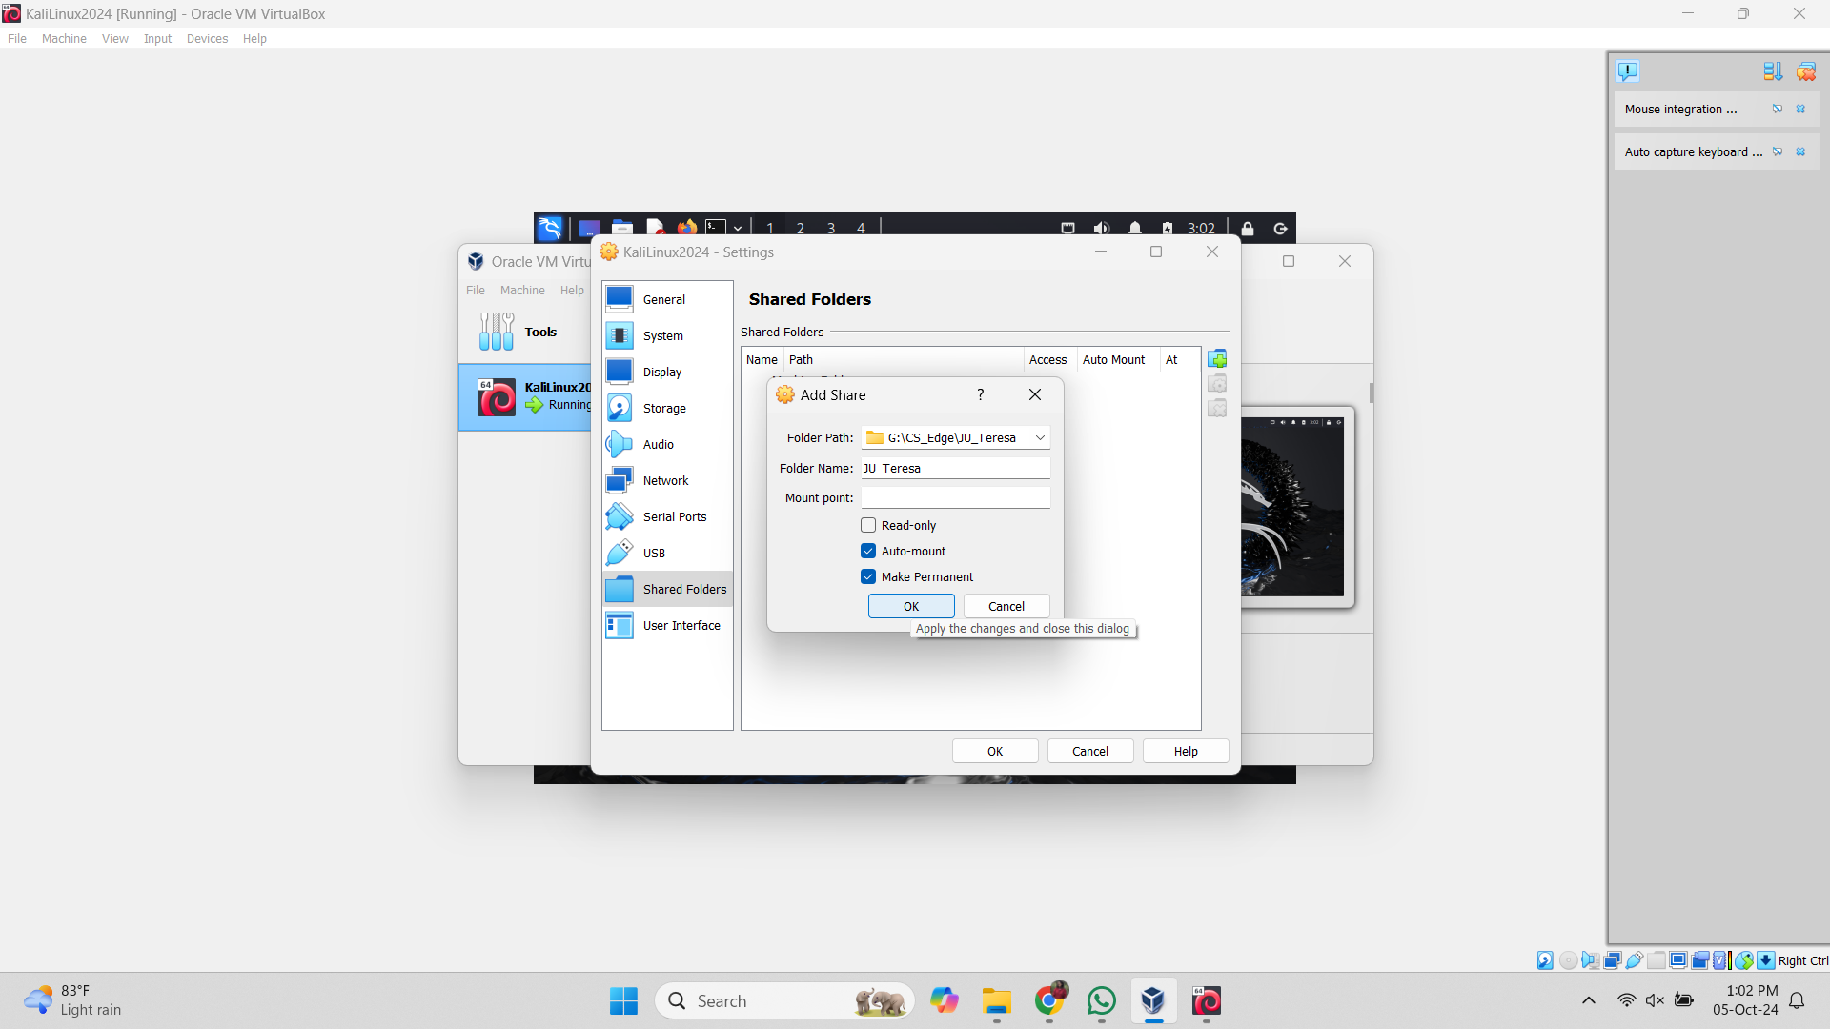

Fig: Creating shared folders

After creating the shared folder, we will analyze and find the details about the sample images using “exiftool image_name” command.

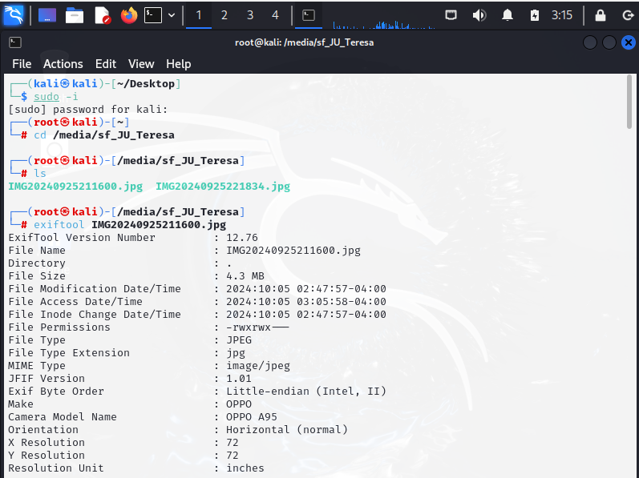

1. Date taken for both samples: 2024.09.25

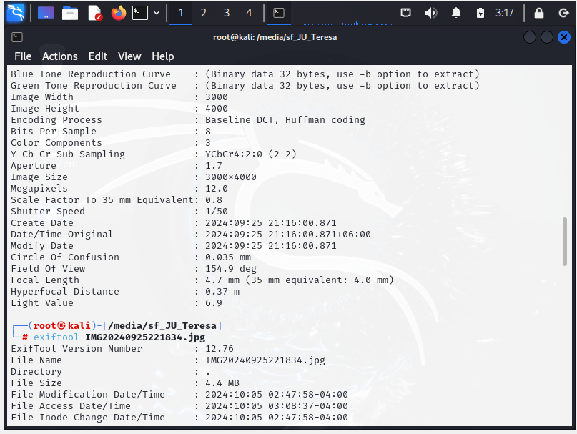

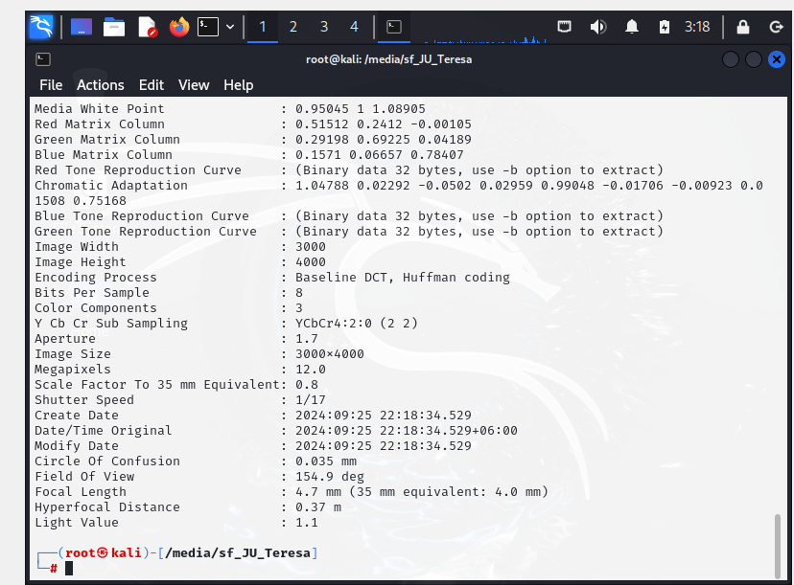

1. Device manufacturer for both photos: Unknown(Oppo), Model name: OPPO A95

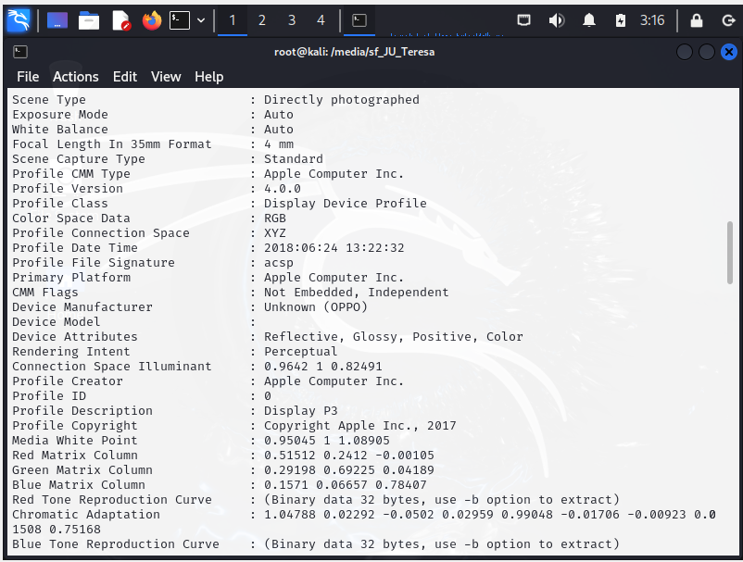

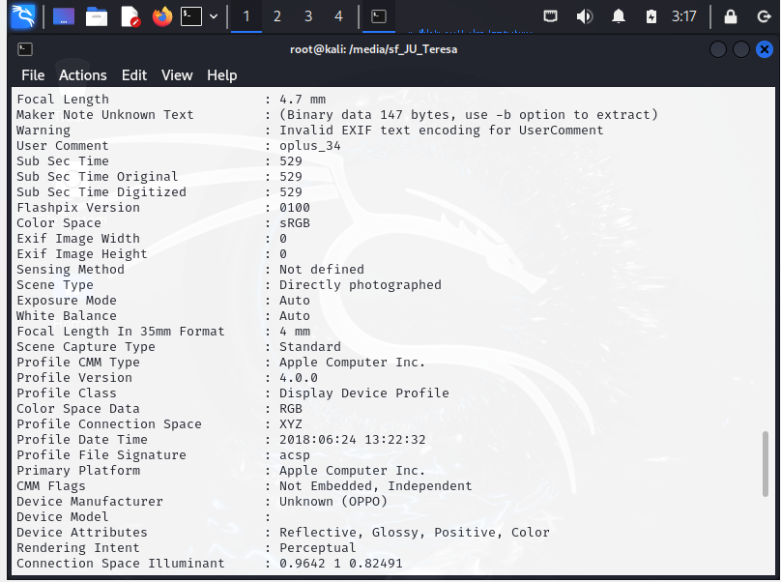

1. Encoding Process for both photos: Baseline DCT, Huffman Coding





1. Image height of both samples: 4000





1. Time taken(first photo): 21:16:00.871+06:00



Time taken(second photo): 22:18:34.529+06:00



Case-02

1. Nmap: Nmap is a network scanning tool used to discover devices on a network and gather information like open ports, services, and operating systems. We can find out the details about all nmap command using “nmap –help” command.
2. To find out my own machine’s IP addresses, I will use “ifconfig” command.

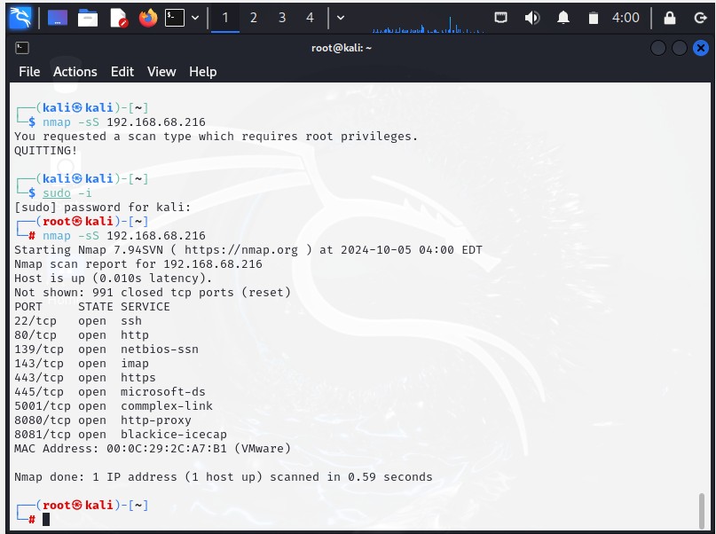

1. 